Appendix 4 to Kintama Research Corp Acoustic Array Proposal. Close up layouts for proposed acoustic detection lines, showing estimated detection radius for proposed acoustic receivers and position. (These figures have been sent as a separate file because of their size)
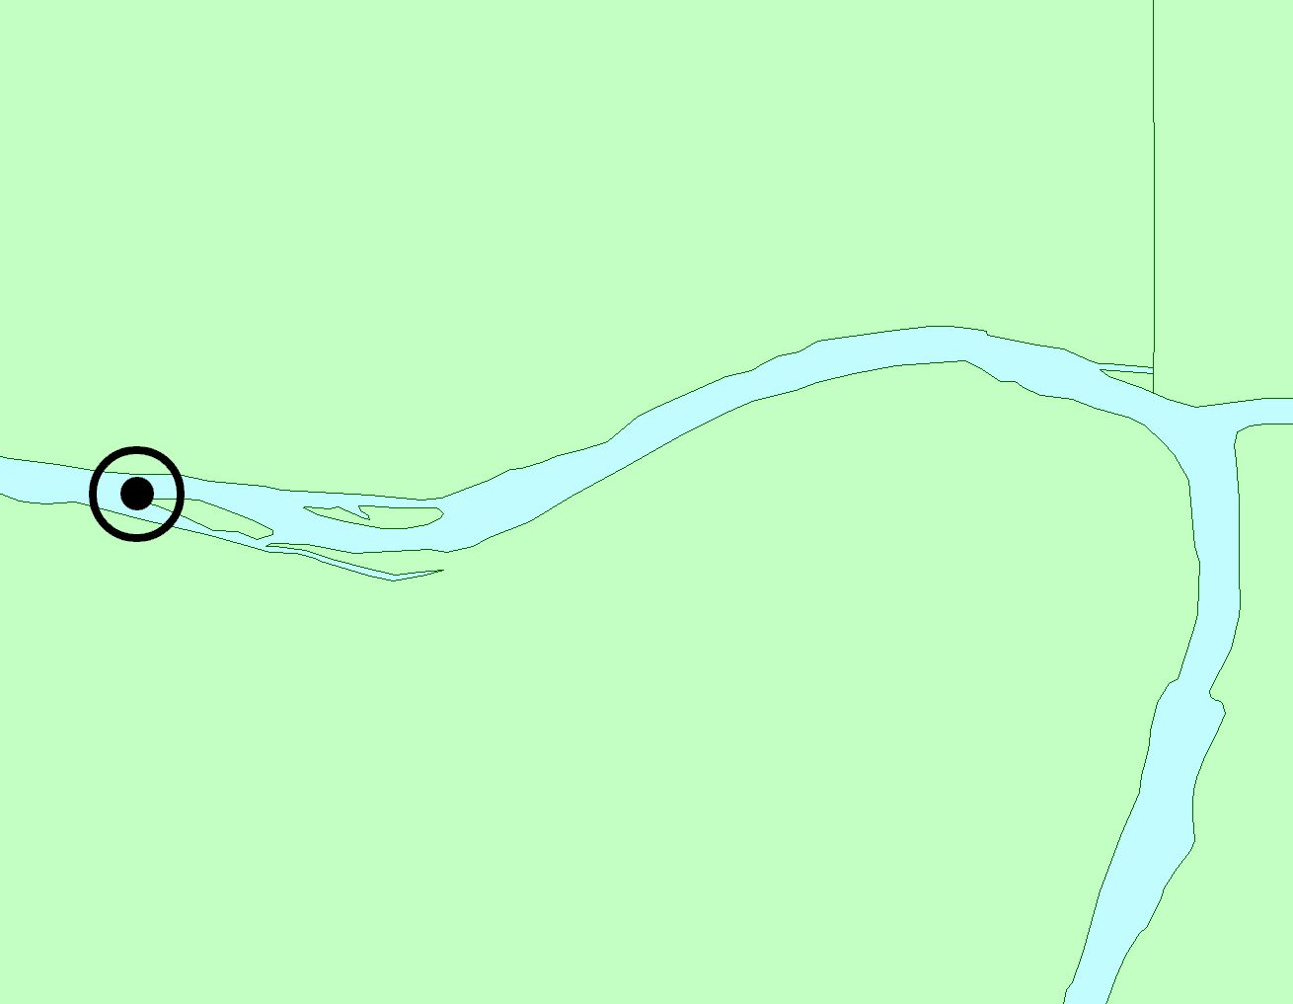
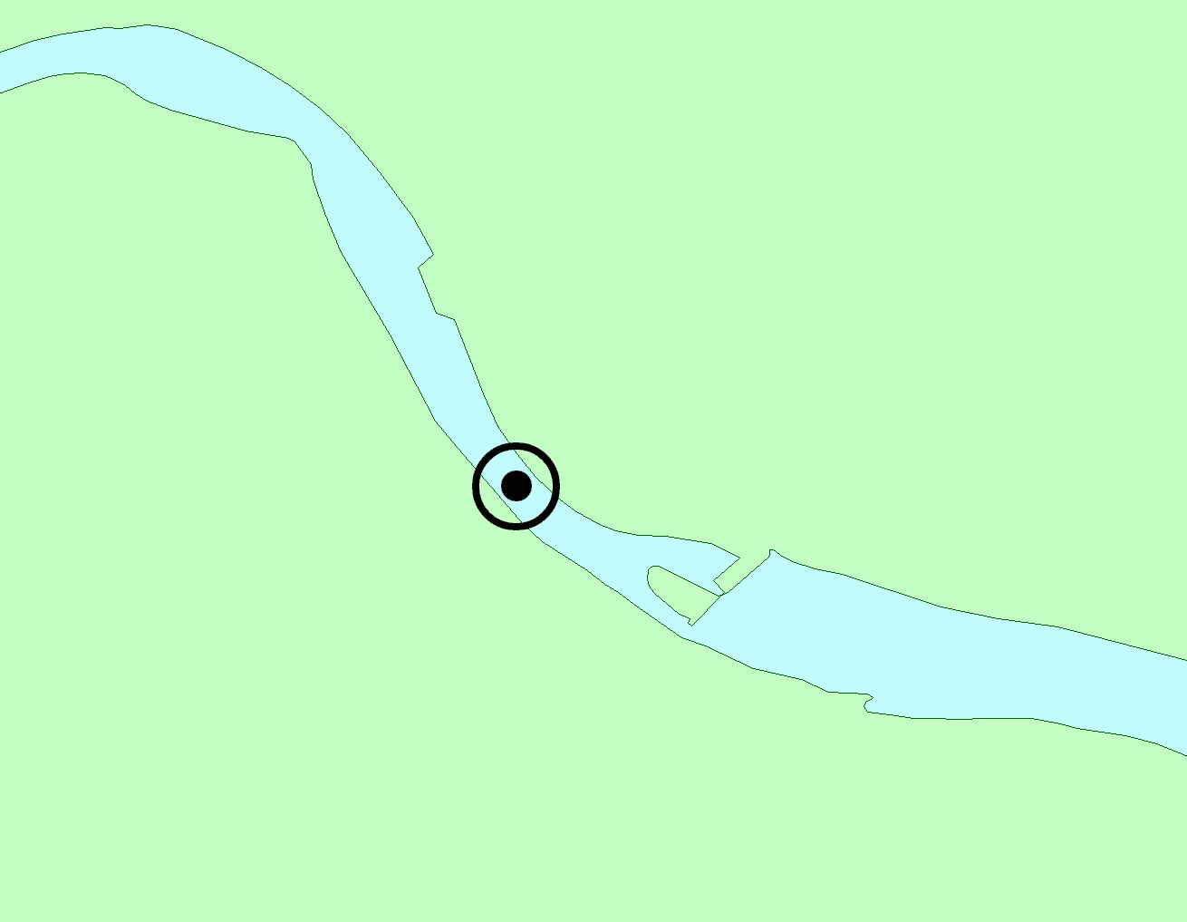
FW1
Snake River
Clearwater
River
FW2
Snake River
Lower Granite
Dam
Boyer Marina
◉ Receiver locations and 350m detection radius

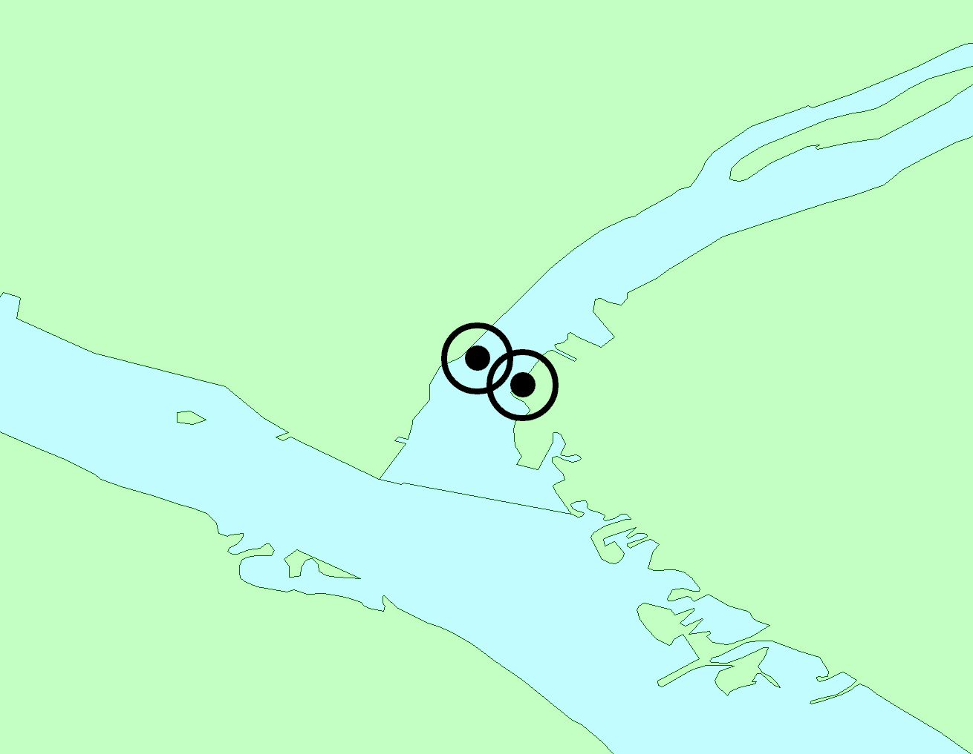
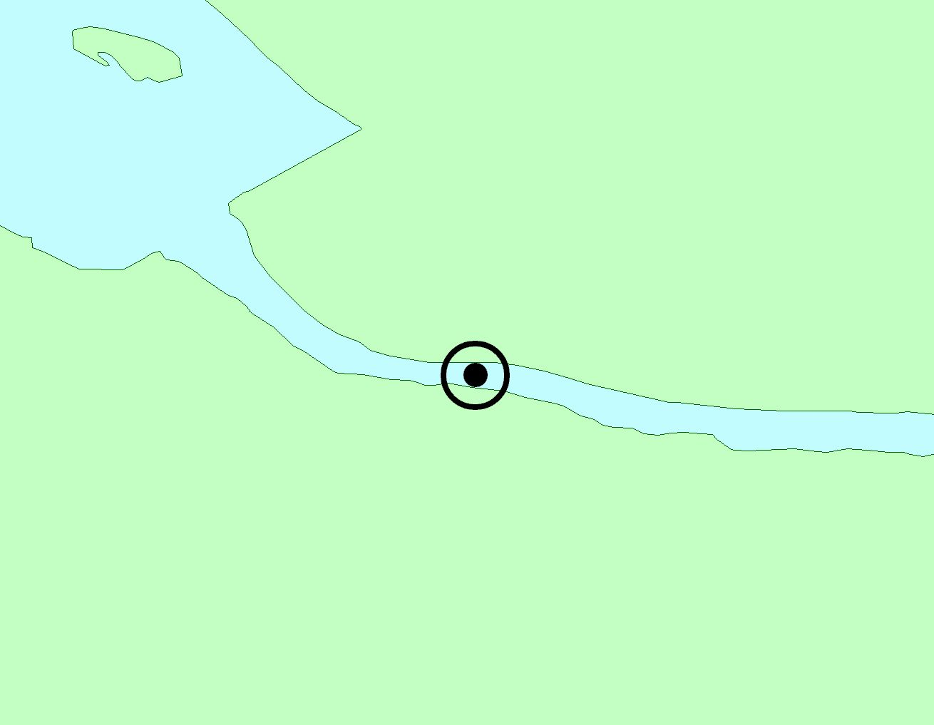
FW3
Snake River
Columbia River
Strawberry I.
FW4
Columbia River
Priest Rapids
Dam
◉ Receiver locations and 350m detection radius
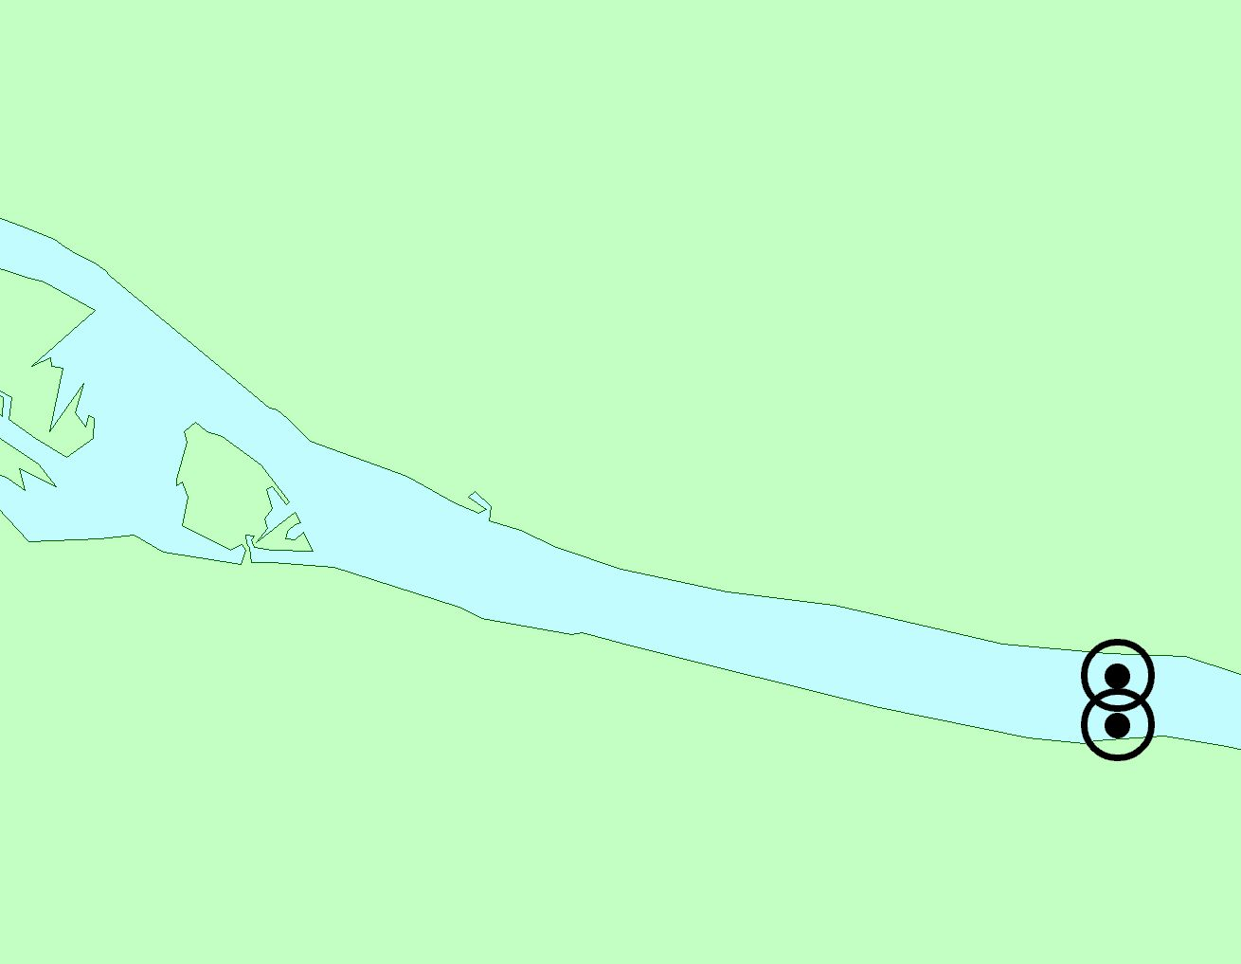
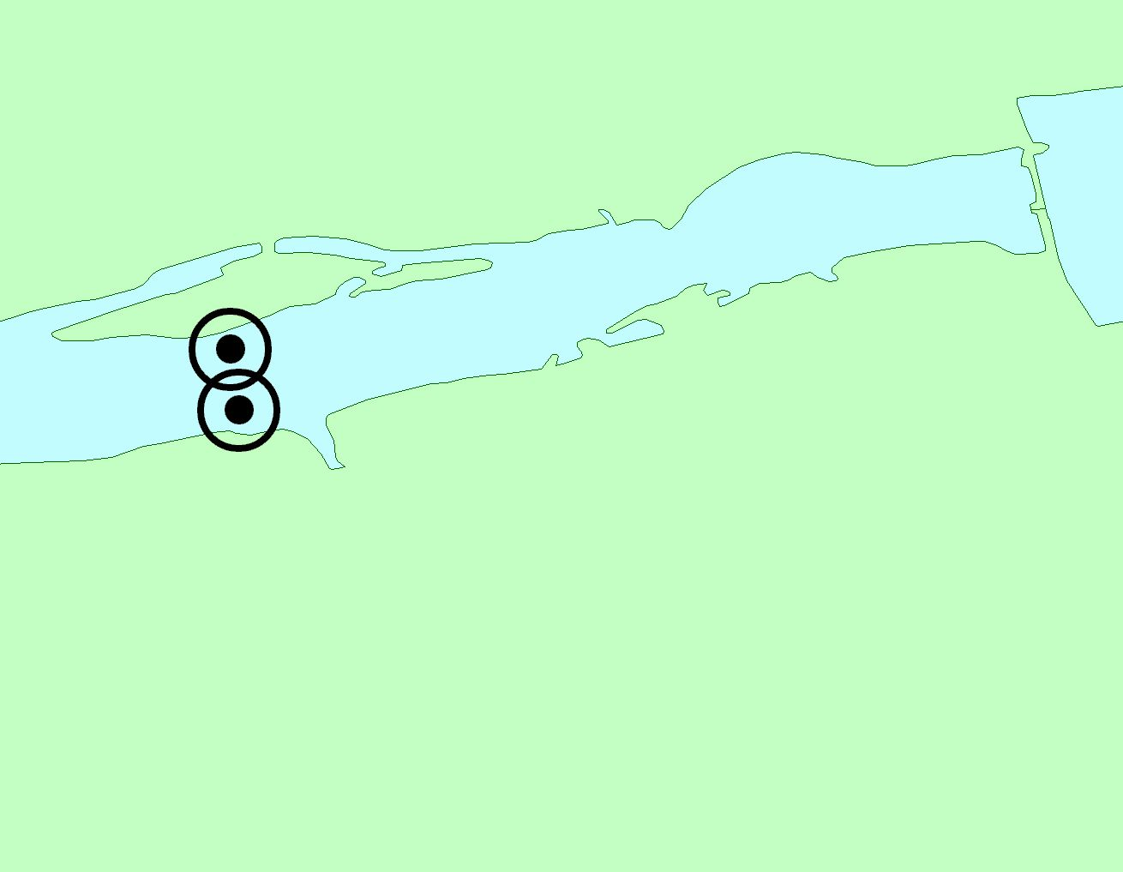
FW5
Columbia River
Yakima River
Bateman
Is.
Columbia R.
FW6
Columbia River
McNary
Dam
◉ Receiver locations and 350m detection radius
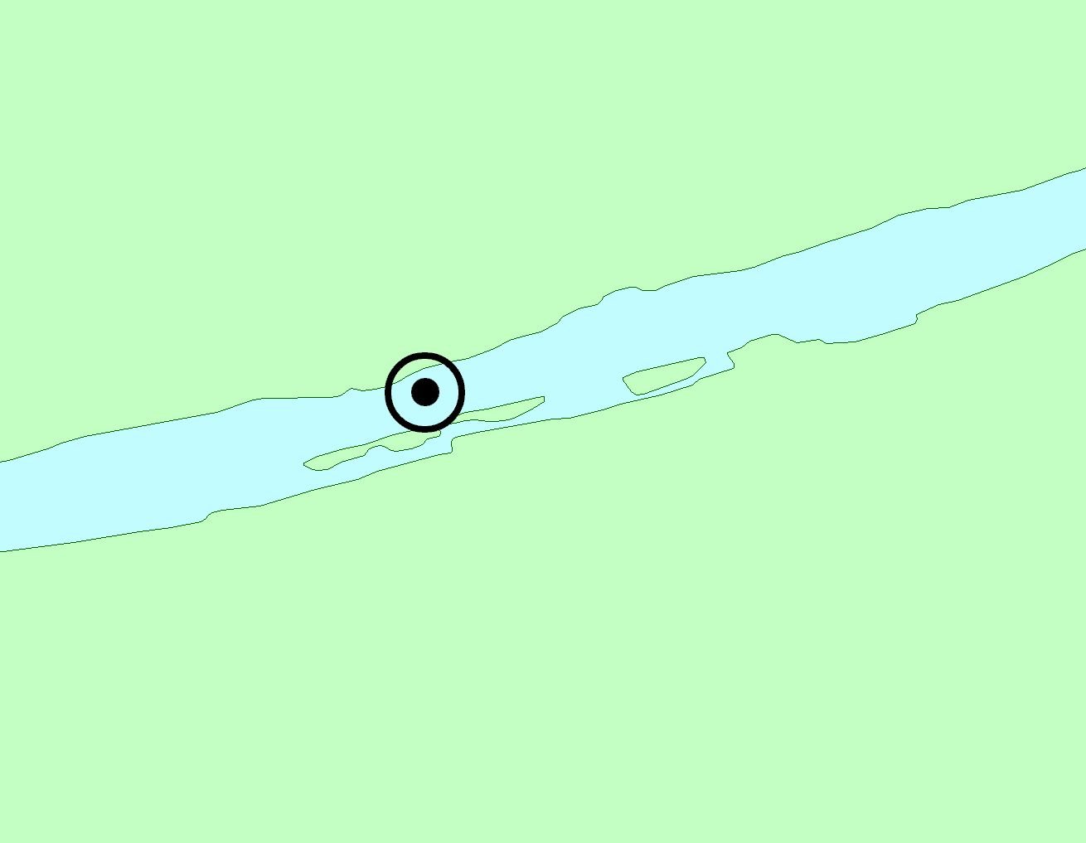
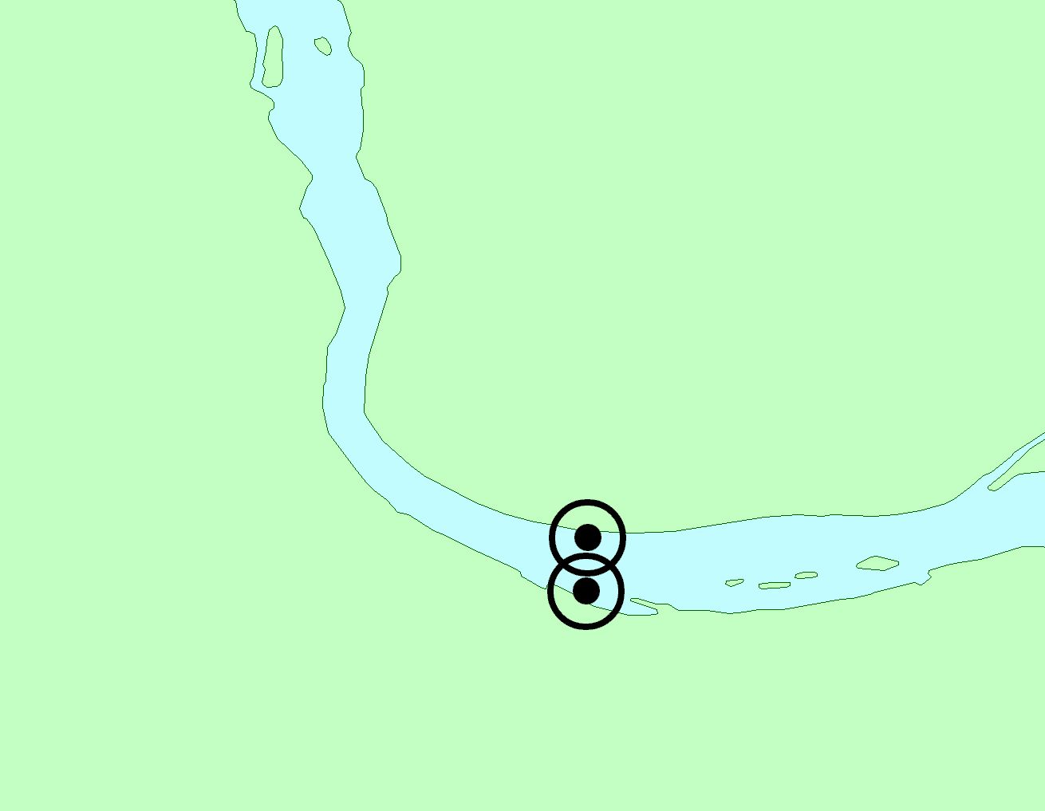
FW7
Columbia River
Maryhill State Park
FW8
Columbia River
The Dalles
Dallesport
◉ Receiver locations and 350m detection radius

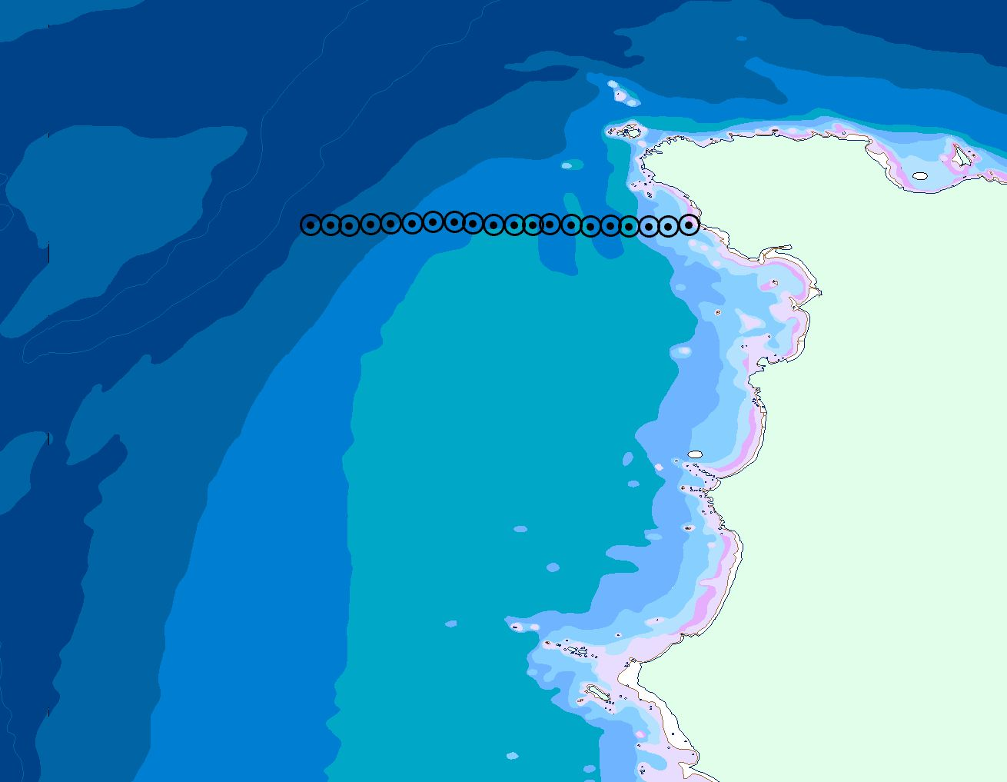
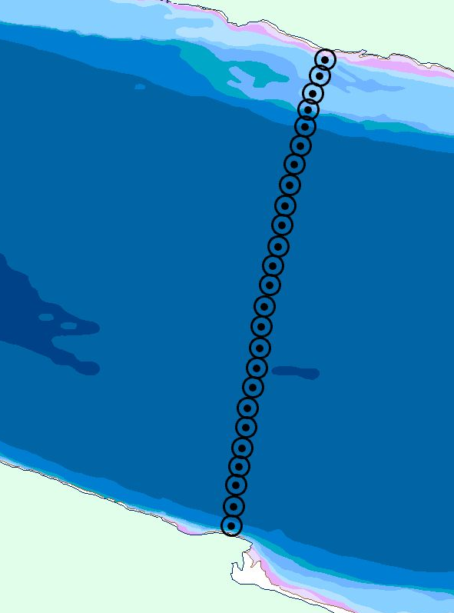
200m
7
8
200m
◉ Receiver locations and 500m detection radius
200m
50m
50m
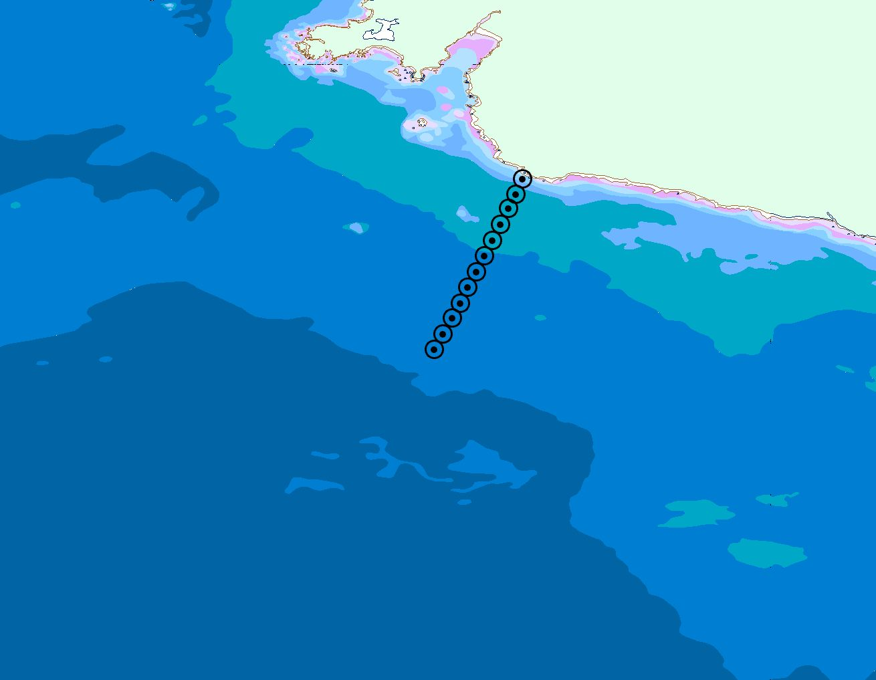
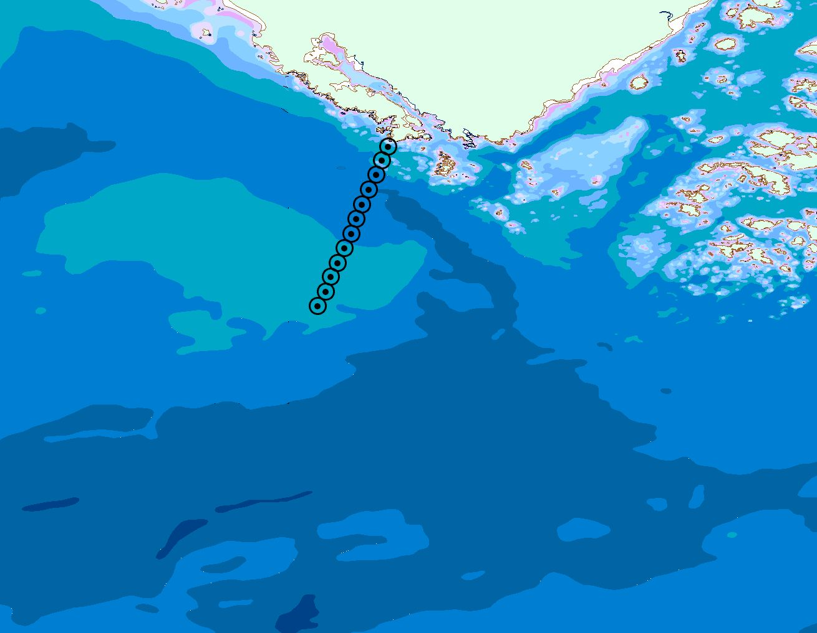
100m
9
100m
10
◉ Receiver locations and 500m detection radius
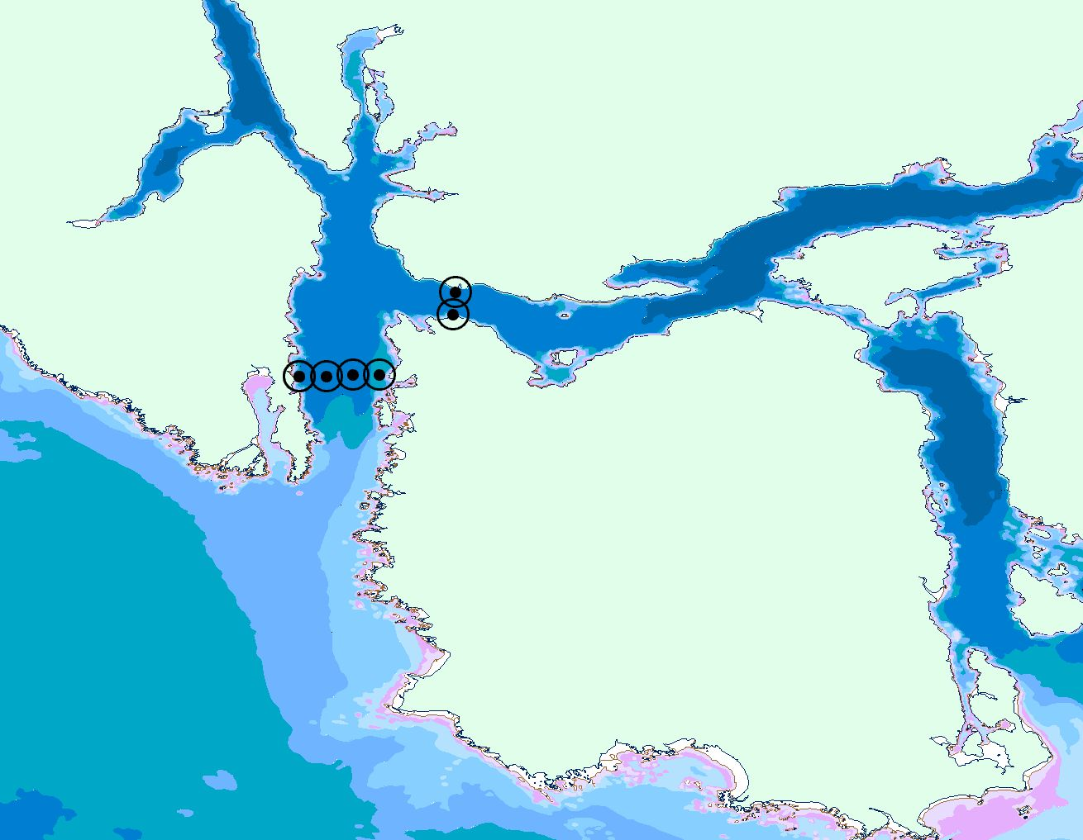
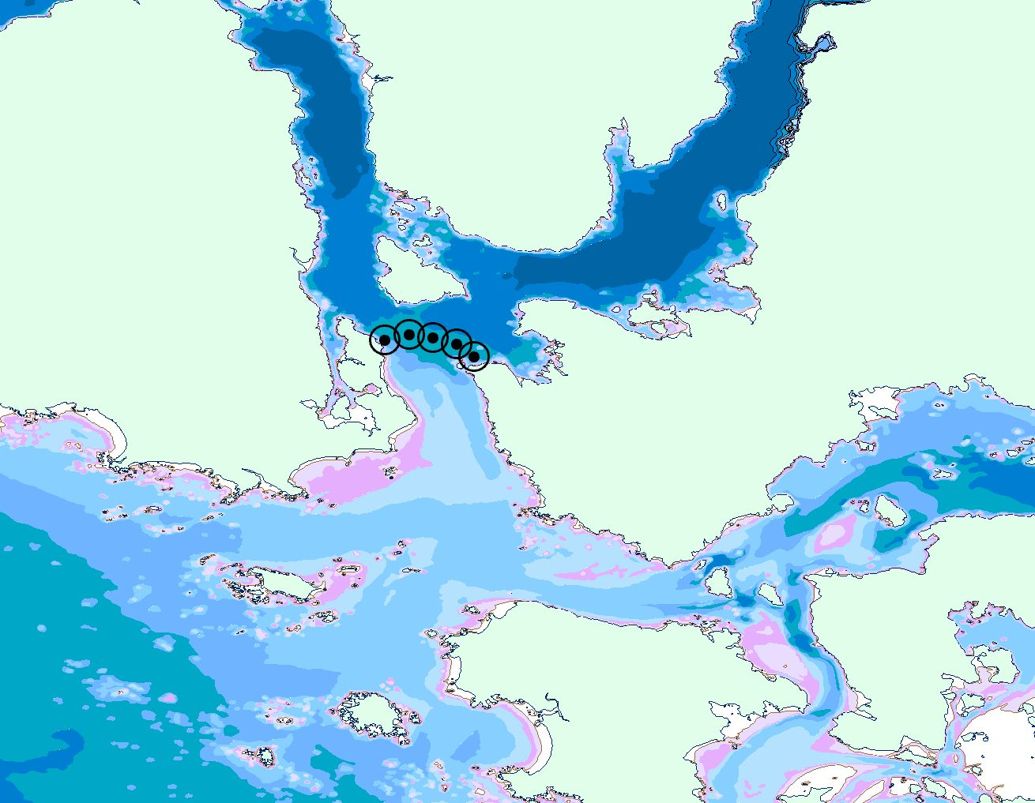
12a
11
12
◉ Receiver locations and 500m detection radius
50m
50m

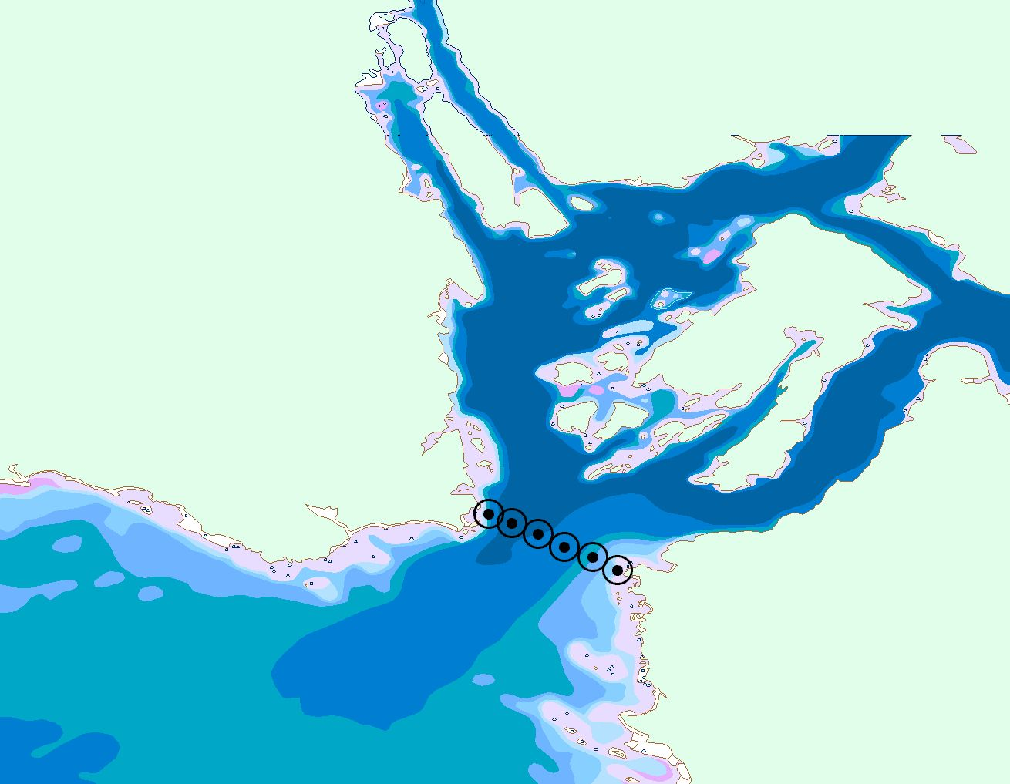
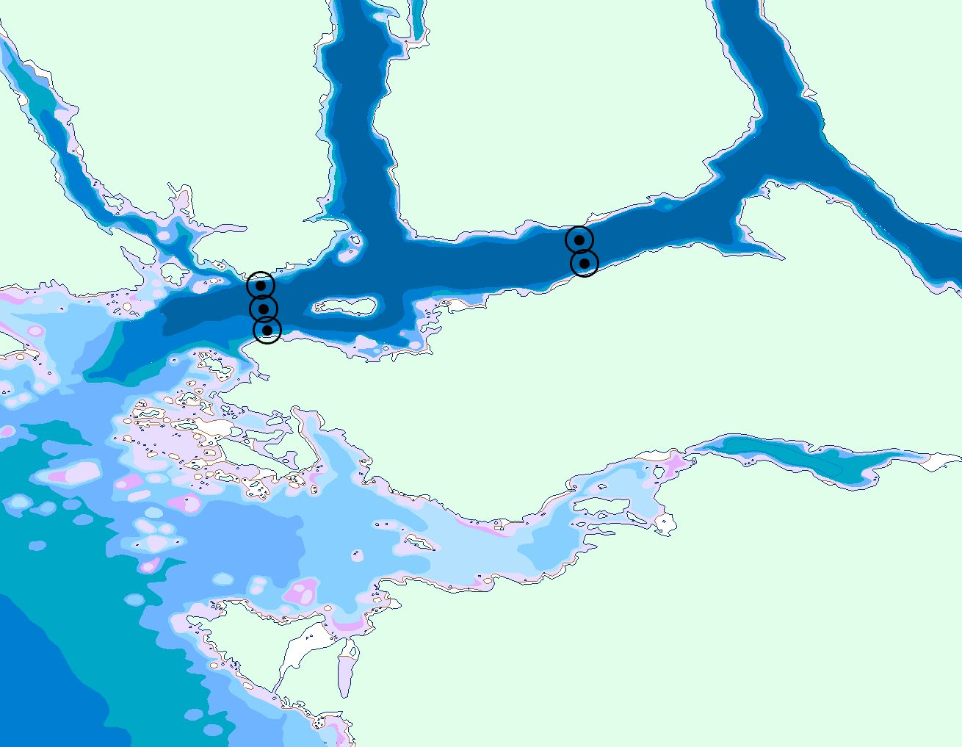
100m
13
14
15
13
◉ Receiver locations and 500m detection radius
100m

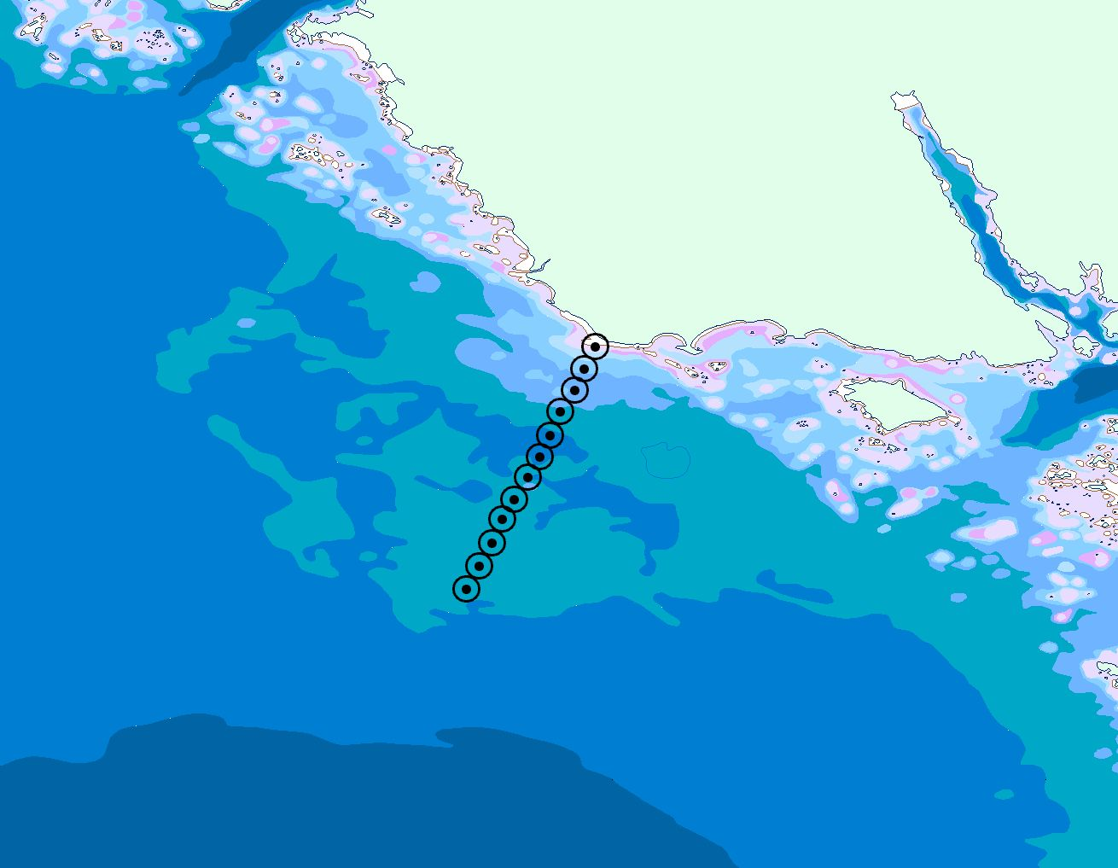
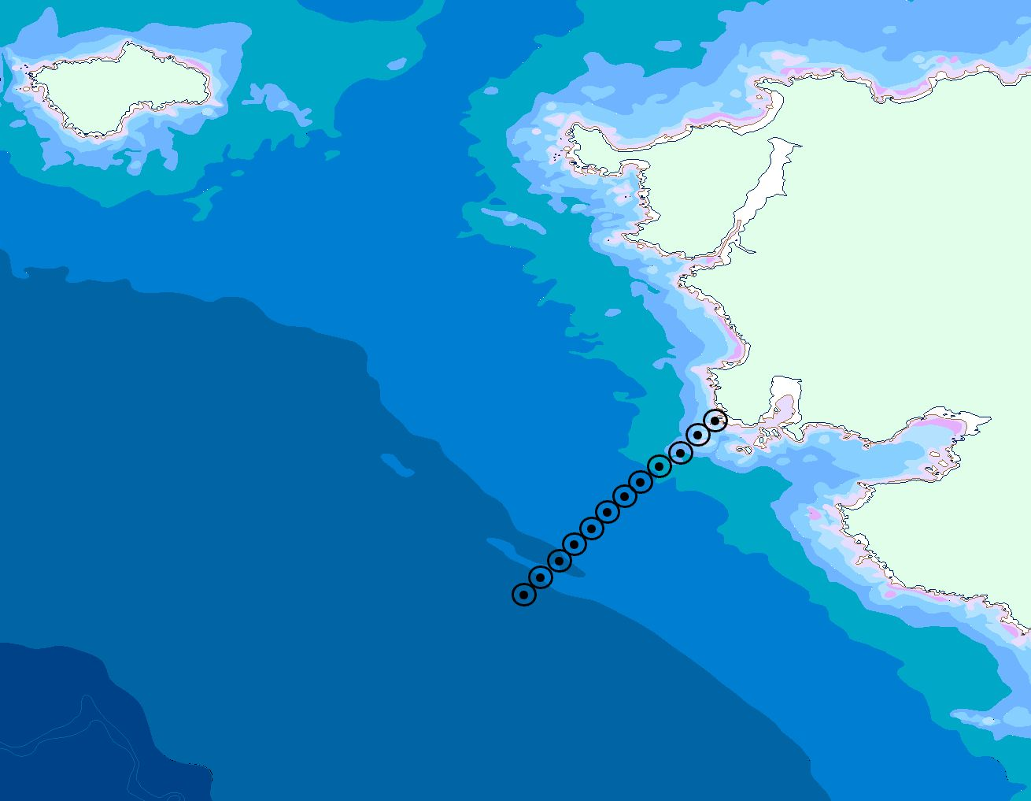
20
16
100m
50m
◉ Receiver locations and 500m detection radius

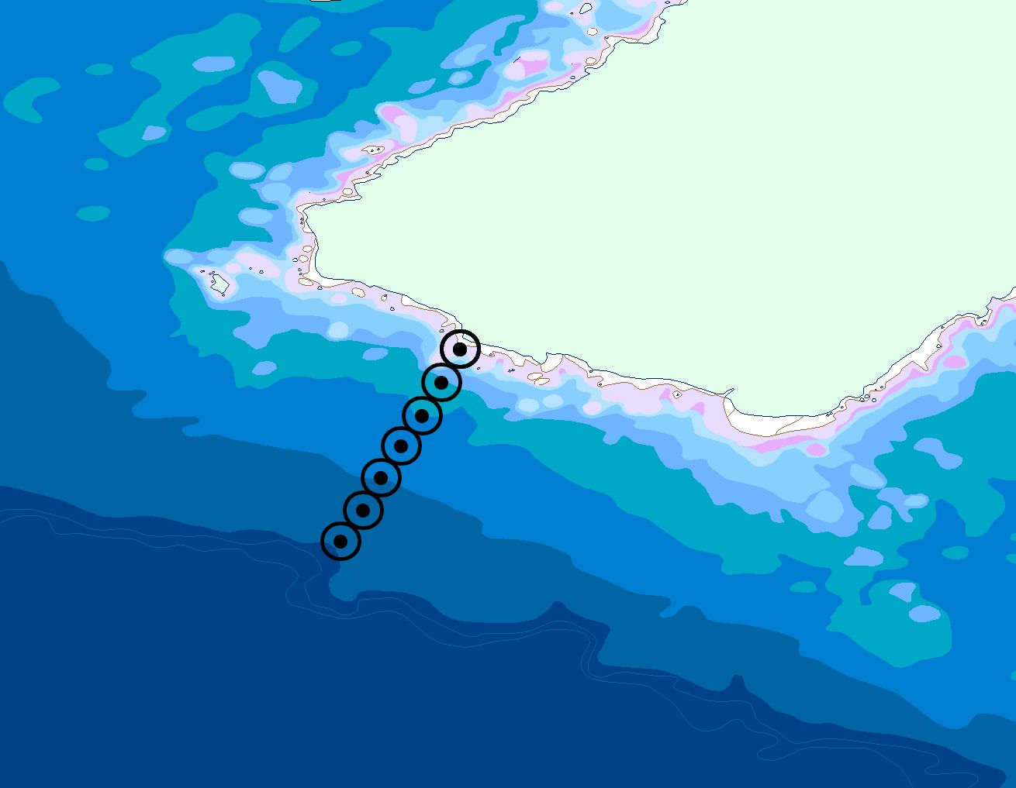
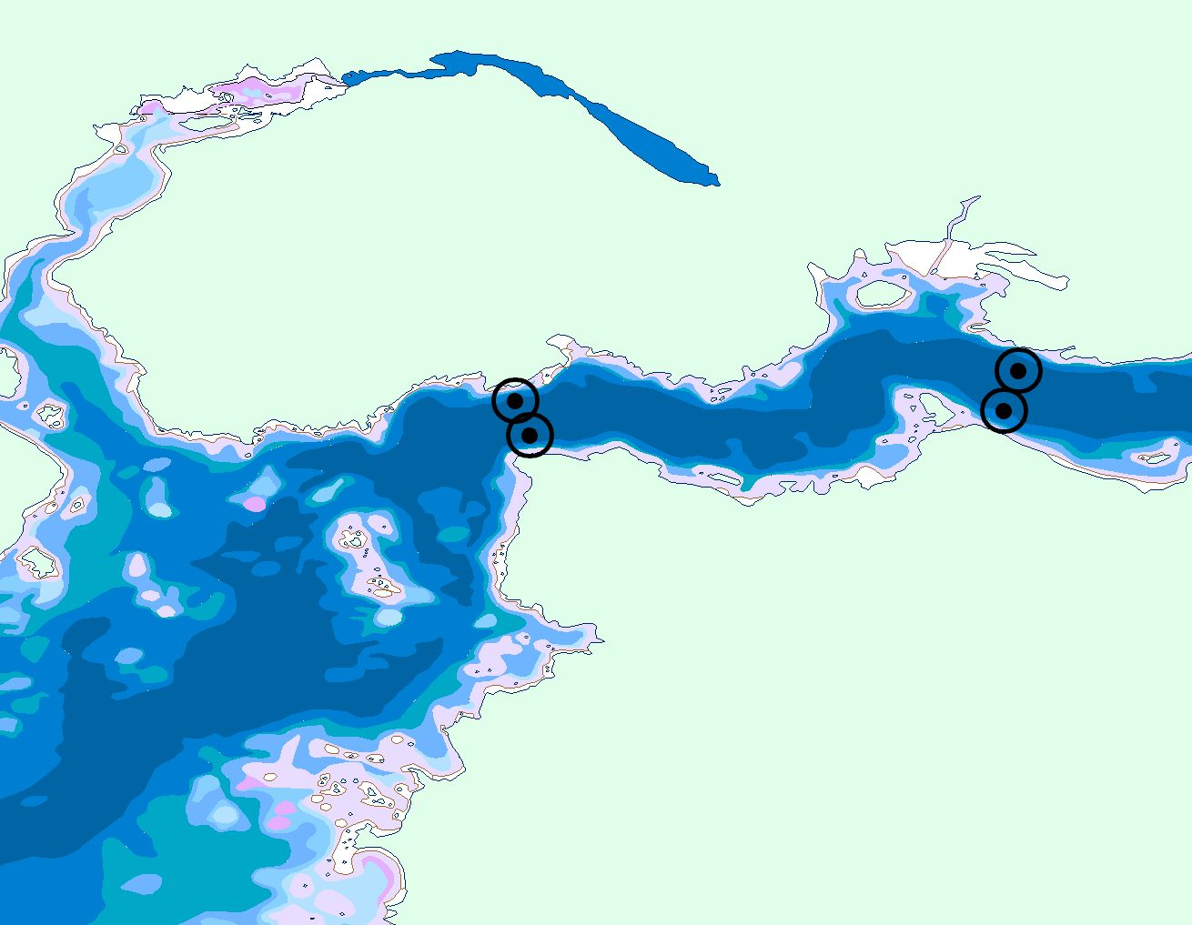
◉ Receiver locations and 500m detection radius
18
19
17
200m

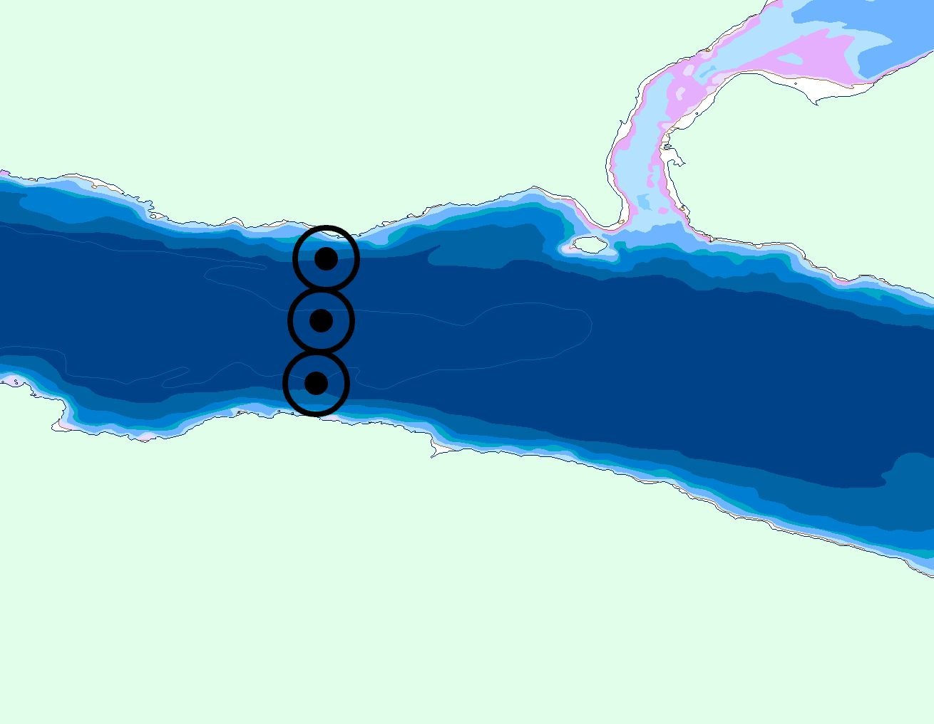
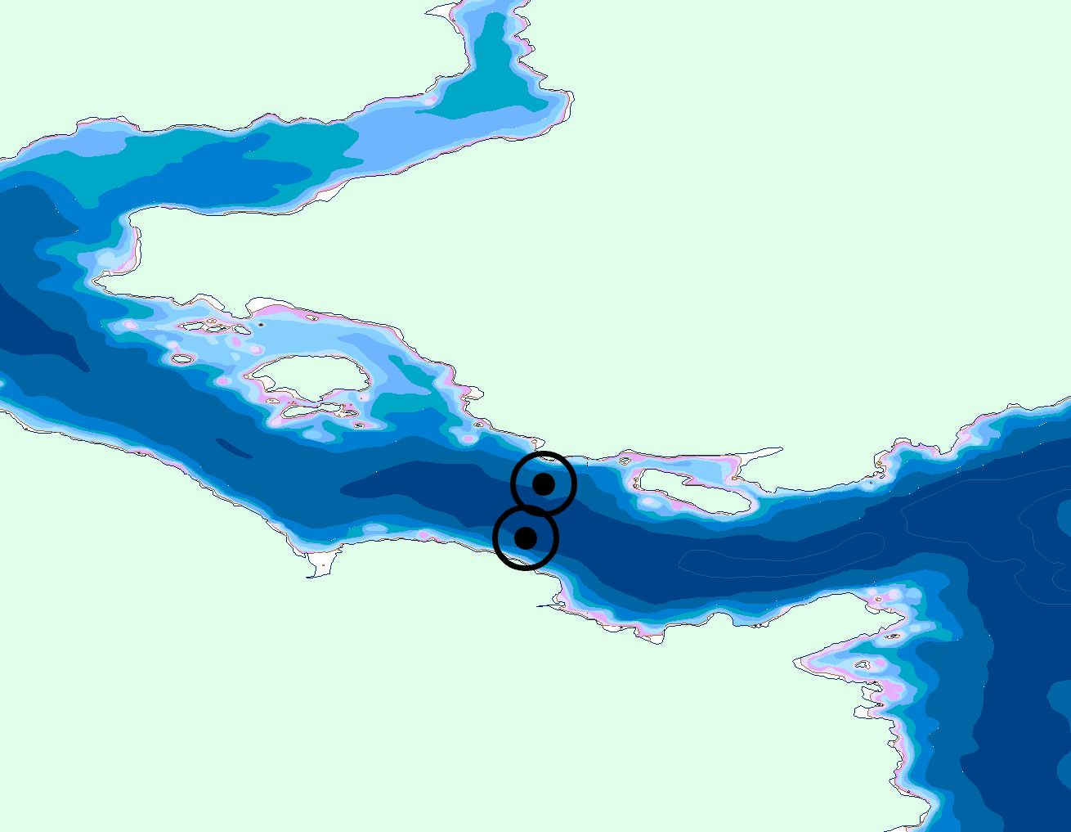
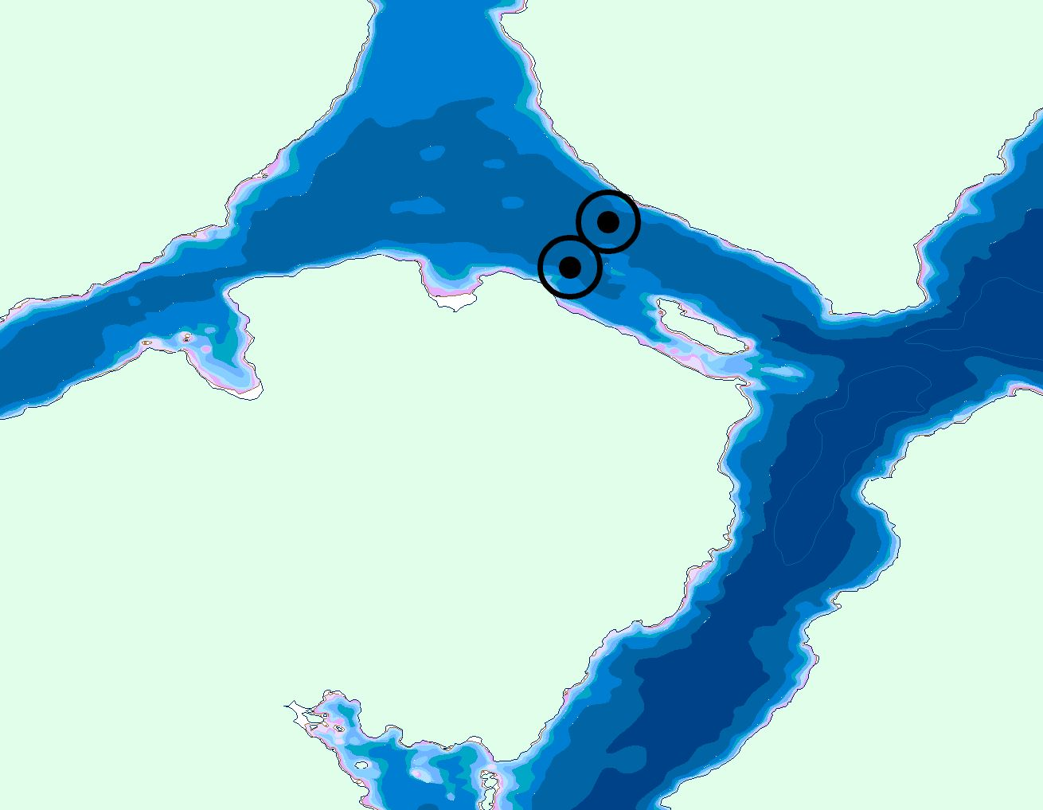
21
◉ Receiver locations and 500m detection radius
22
23
200m
200m
200m

